Identify the process that is occurring in the diagram below and discuss the role of RNA polymerase, ribonucleotides, mRNA, DNA (non-template), and DNA (template) within this process.

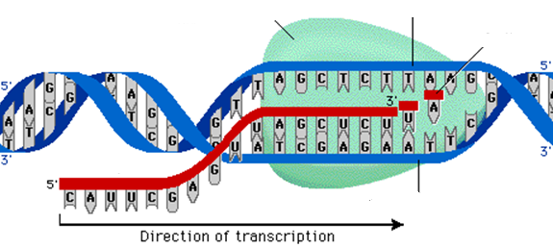

Identify the process that is occurring in the diagram below and discuss the role of mRNA, the ribosome, tRNA, amino acids, codons, anticodons, peptide bonds, and polypeptides.

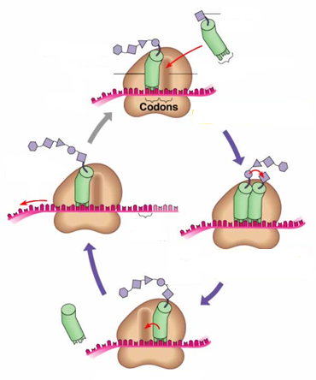

Create a concept map in which you demonstrate how the following terms are related.

|  |  |  |  |
| --- | --- | --- | --- |
| **Gene** | **DNA** | **Polypeptide** | **Amino acids** |
| **Transcription** | **Genotype** | **Mutation** | **Alleles** |
| **Phenotype** | **Protein** | **Translation** | **Ribosome** |

Transcribe and translate the below strand of DNA with no mutation.

**No Mutation**

|  |  |  |  |  |  |
| --- | --- | --- | --- | --- | --- |
| DNA | ACC | GAT | AAT | GTA | GTC |
| *mRNA* |  |  |  |  |  |
| *polypeptide* |  |  |  |  |  |

For each of the following strands of DNA, introduce the indicated type of mutation and explain the ultimate impact on the polypeptide sequence.

**Silent Mutation**

|  |  |  |  |  |  |
| --- | --- | --- | --- | --- | --- |
| DNA | ACC | GAT | AAT | GTA | GTC |
| *mRNA* |  |  |  |  |  |
| *polypeptide* |  |  |  |  |  |

**Missense Mutation**

|  |  |  |  |  |  |
| --- | --- | --- | --- | --- | --- |
| DNA | ACC | GAT | AAT | GTA | GTC |
| *mRNA* |  |  |  |  |  |
| *polypeptide* |  |  |  |  |  |

**Nonsense Mutation**

|  |  |  |  |  |  |
| --- | --- | --- | --- | --- | --- |
| DNA | ACC | GAT | AAT | GTA | GTC |
| *mRNA* |  |  |  |  |  |
| *polypeptide* |  |  |  |  |  |

**Frameshift (Insertion) Mutation**

|  |  |  |  |  |  |
| --- | --- | --- | --- | --- | --- |
| DNA | ACC | GAT | AAT | GTA | GTC |
| *mRNA* |  |  |  |  |  |
| *polypeptide* |  |  |  |  |  |

**Frameshift (Deletion) Mutation**

|  |  |  |  |  |  |
| --- | --- | --- | --- | --- | --- |
| DNA | ACC | GAT | AAT | GTA | GTC |
| *mRNA* |  |  |  |  |  |
| *polypeptide* |  |  |  |  |  |

In guinea pigs, the allele for short hair is completely dominant over the allele for long hair.

1. 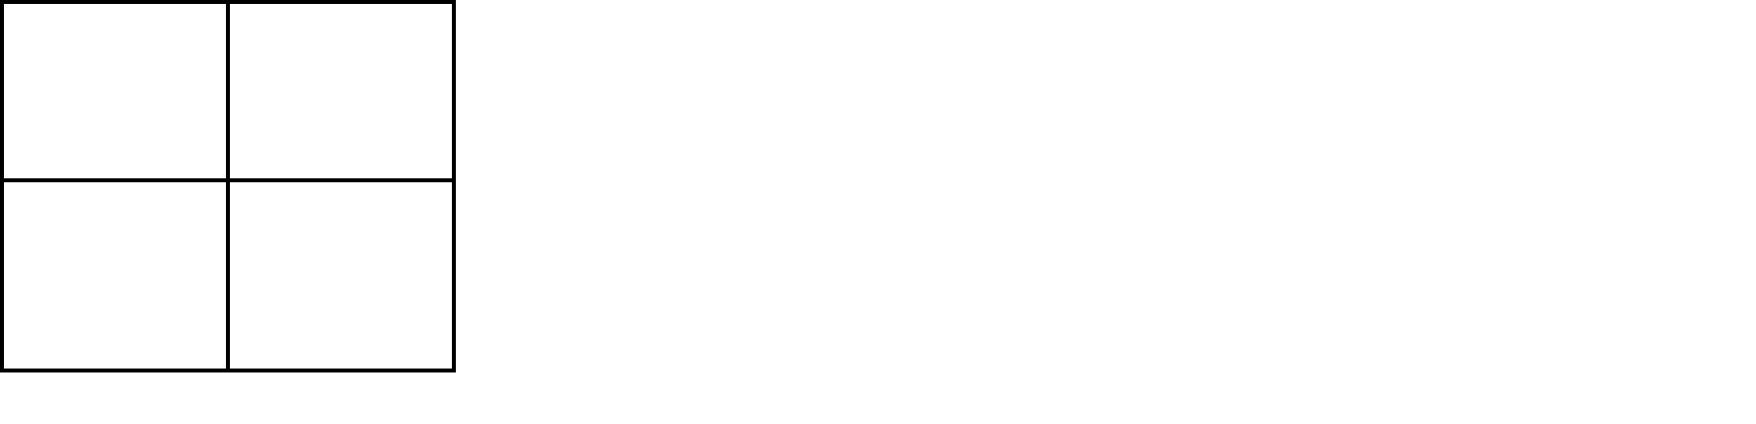Show the cross for a true-breeding shorthaired guinea pig and a longhaired guinea pig. What are the phenotypic ratios of offspring in the F1 generation?
2. If you crossed two F1 generation guinea pigs, what would be the phenotypic ratios for the F2 generation?

In rabbits, grey hair is completely dominant to white hair. Also in rabbits, black eyes are completely dominant to red eyes.

1. A male rabbit (homozygous for gray hair and red eyes) is crossed with a female rabbit (homozygous for white hair and heterozygous for black eyes). Determine the phenotypic ratio of offspring for this cross.

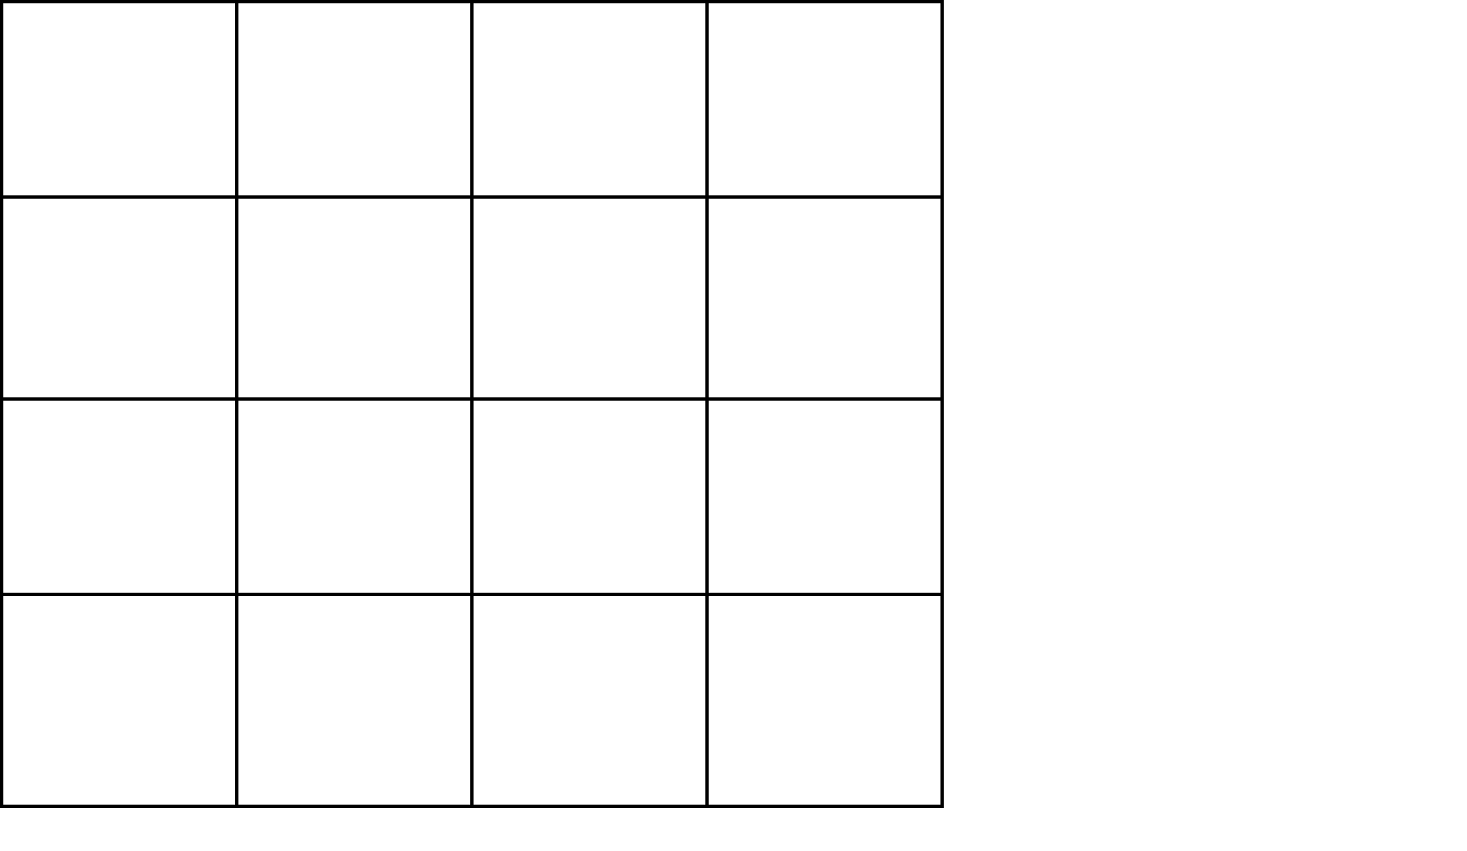

In fruit flies, eye color is a sex-linked trait. Red eye color is completely is dominant to white.

Predict the phenotypic ratios of offspring for the following crosses:

1. A white eyed female with a red-eyed male



1. A homozygous red-eyed female and a white-eyed male



1. A red eyed female (heterozygous) and a red-eyed male.



What patterns do you observe from performing these three crosses for a sex-linked trait?

In corn, purple kernels (D) are dominant over yellow (d), and smooth kernels (G) are dominant over shrunken (g). Two parent corn strains are crossed that are heterozygous for both purple and smooth kernels. The observed number of kernels for each phenotype from this cross follows in the table below.

|  |  |
| --- | --- |
| **Phenotype** | **Number of Observed Kernels** |
| purple, smooth | 216 |
| purple, shrunken | 79 |
| yellow, smooth | 65 |
| yellow, shrunken | 21 |

State the null hypothesis:

|  |  |  |  |  |
| --- | --- | --- | --- | --- |
| **Phenotype** | **Observed (o)** | **Expected (e)** | **(o-e)** | **(o-e)2/e** |
|  |  |  |  |  |
|  |  |  |  |  |
|  |  |  |  |  |
|  |  |  |  |  |
|  | **Total=** |  |  | **Sum (X2)=** |

Interpret the chi square statistic:

You discover corn growing in a different area of the field where the soil has been contaminated with a spilled contained of liquid fertilizer and has a very low pH relative to the rest of the area. Assume these corn plants are offspring of the same parents from the above cross.

|  |  |
| --- | --- |
| **Phenotype** | **Number of Observed Kernels** |
| purple, smooth | 132 |
| purple, shrunken | 83 |
| yellow, smooth | 112 |
| yellow, shrunken | 95 |

State the null hypothesis:

|  |  |  |  |  |
| --- | --- | --- | --- | --- |
| **Phenotype** | **Observed (o)** | **Expected (e)** | **(o-e)** | **(o-e)2/e** |
|  |  |  |  |  |
|  |  |  |  |  |
|  |  |  |  |  |
|  |  |  |  |  |
|  | **Total=** |  |  | **Sum (X2)=** |

In light of these chi square results, how do these corn plants compare to those found in the rest of the field?The following three pedigrees track the same trait through three different families. Which inheritance pattern is most likely repsonsible for the observed pattern in all three families? Justify your claim with evidence from all three pedigrees.

**Family A**

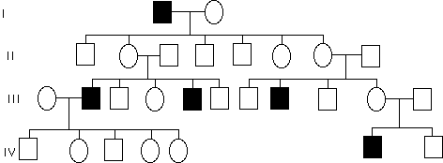

**Family B**

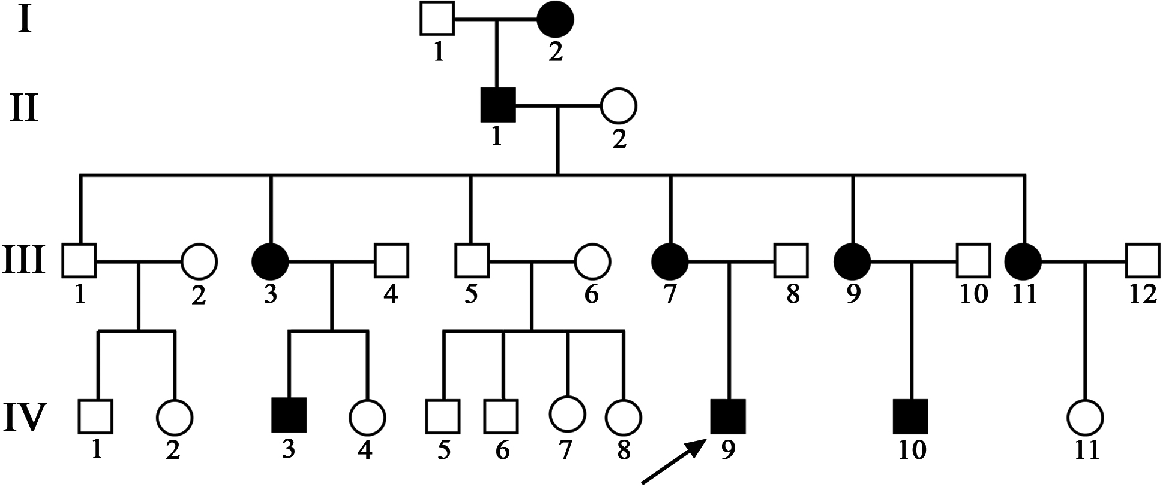

**Family C**

